By: Charlen Baloukjy
03/11/2026
Web Application Pentesting – Injectics CTF (TryHackMe)
- Purpose:
The purpose of this CTF is to exploit a web server using injection techniques and retrieve 2 flags.
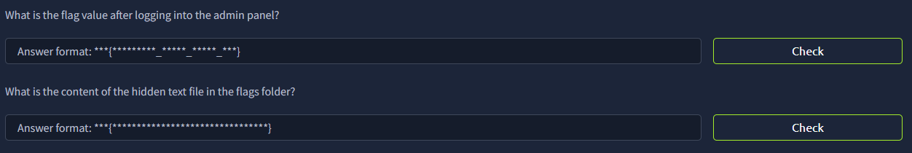
- Methodology:
As usual, I first used nmap to discover open ports on the target host by using “nmap -sS -sC -p- <target IP>”
The results showed ssh and http being open.
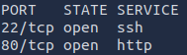
Next, I used gobuster to enumerate directories for the webpage and see what is available. The command I used is: gobuster dir -u http://<target IP> -w <wordlist> -x php,json,html,txt
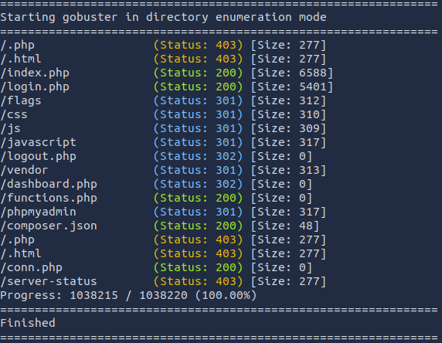
Looking at the results from gobuster, we can see that the 2nd flag will be in /flags, which means we must access it eventually.
For now, since http is open, I opened FireFox browser and looked up the target host using “http://<target IP>”. A normal webpage is shown.

After inspecting the webpage for a bit, I was able to only visit the “Home” and “Login” pages of the website. Visiting the “Login” page showed a log in form.
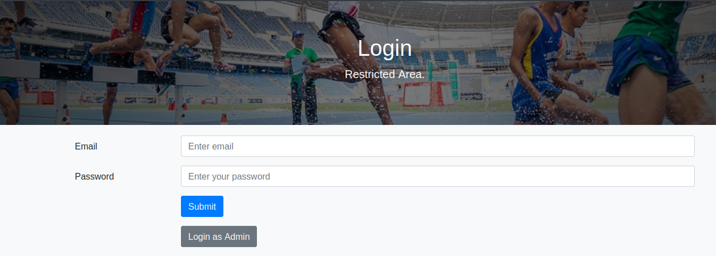
Since I don’t have any way of logging in, I checked the page source of the homepage to see if I can find something of interest. I was able to find a note saying the following:
Interesting. Next, I visited the mail.log directory of the webpage where I was able to see a message written by the developers.
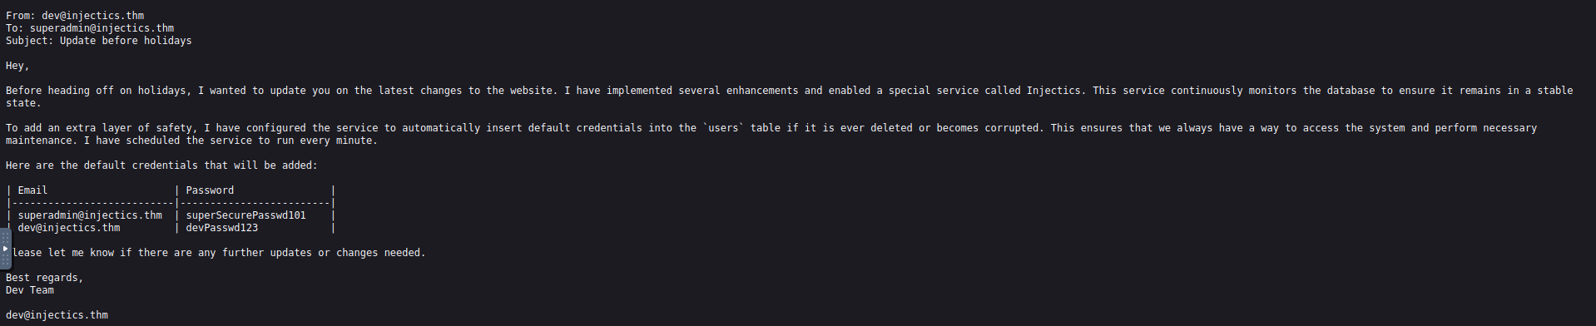
Long story short, the message reveals that there is a background monitoring service called “Injectics” that runs every minute and restores the “users” table with default credentials if it becomes corrupted or deleted. This implies that if an attacker manages to delete the table through SQL Injection, the service will automatically recreate it with known credentials, allowing login as the superadmin user.
Then, I looked at the source code of the “Login” page where I was able to find a javascript code (script.js) that basically acts as a security filter for SQL injection.
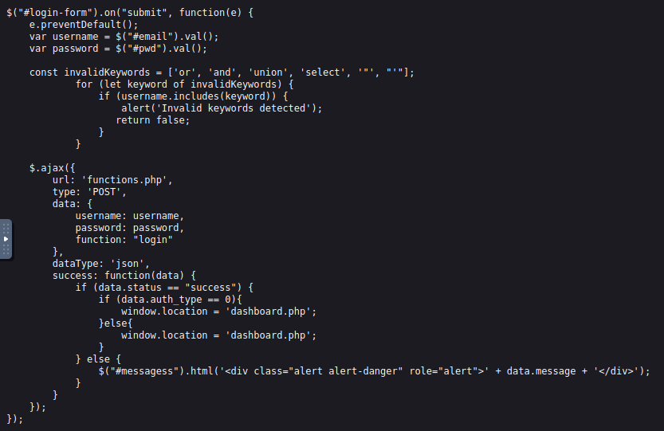
Basically, this script intercepts the login form submission, prevents the page from reloading, checks the username for certain SQL-related keywords, and then sends the username and password to functions.php using an AJAX request. If the server returns a successful response, the user is redirected to dashboard.php; otherwise, an error message is displayed.
Next, I went to composer.json directory to see what versions of libraries are allowed.
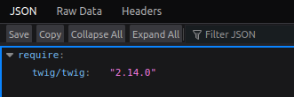
We can see that the webserver is using the twig template engine, which might be susceptible to SSTI (Server-Side Template Injection).
Using Burp Suite, I intercepted a login request and sent it to the repeater to try multiple SQLi commands in hope of logging in.
After multiple tries and research, I was able to log in using the command: ‘||1;#
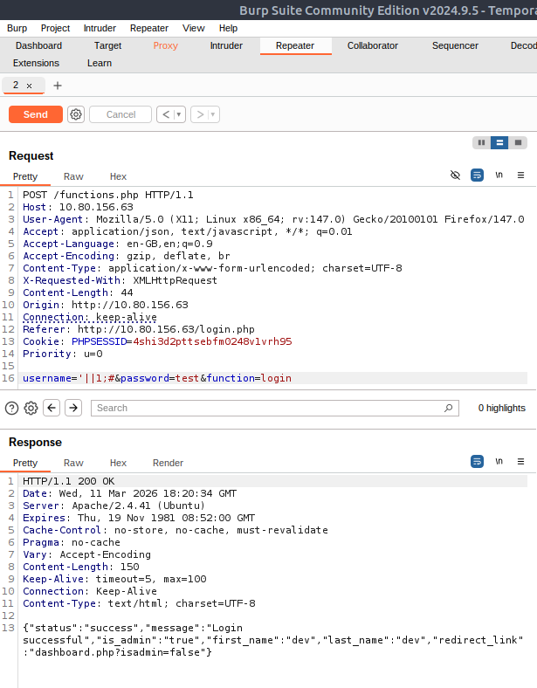
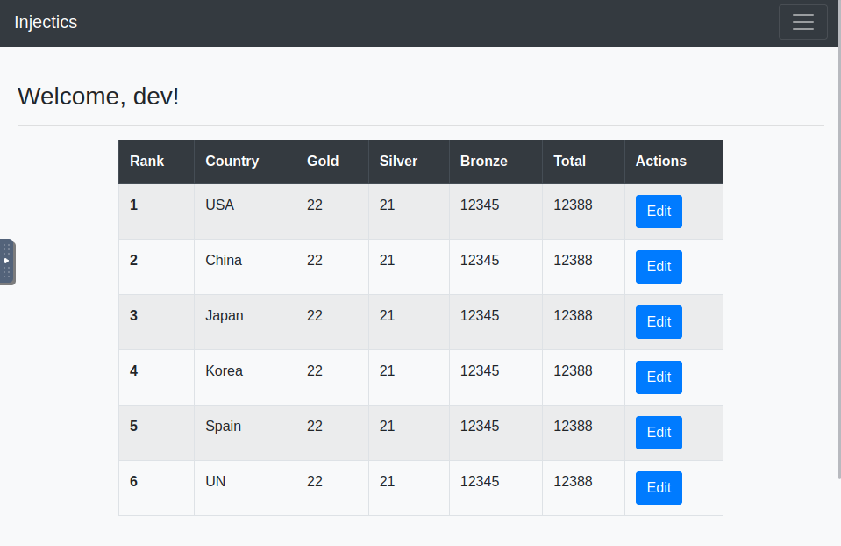
Notice we’re logged in as dev. We still need to log in as superadmin so we can get the flags. Recall the “Injectics” service that checks the ‘users’ table in the database. We must delete the ‘users’ table.
I then press on the edit button to edit one of the ranks so I can inject SQLi commands to drop the ‘users’ table. After multiple failures with some commands, the following command successfully dropped the table:
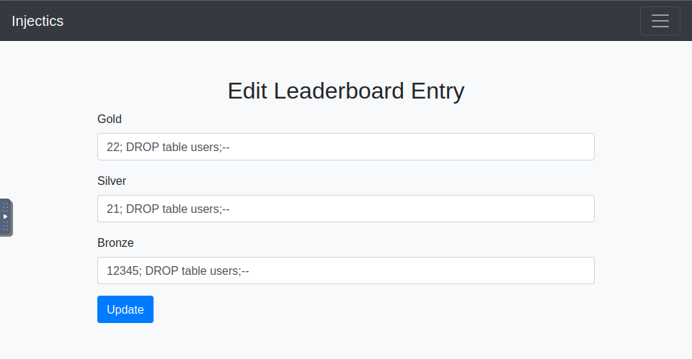
After waiting 1-2 minutes, I used the login credentials of superadmin that were in mail.log to log in. The first flag is shown above the leaderboard table:
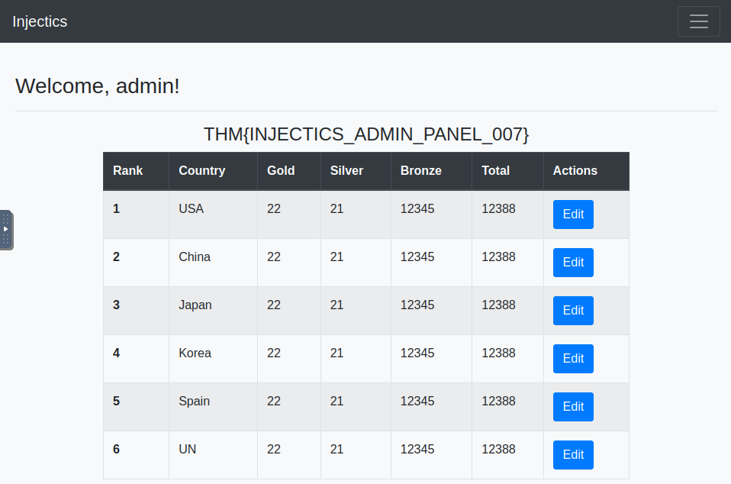
The next thing to do is try to get the 2nd flag that is in the flags folder as per gobuster’s results. I tried accessing /flags of the webpage, but I didn’t have permission. I should find a way to escalate my privileges so I can retrieve the flag.
After looking around, there is a Profile tab where you can update information.
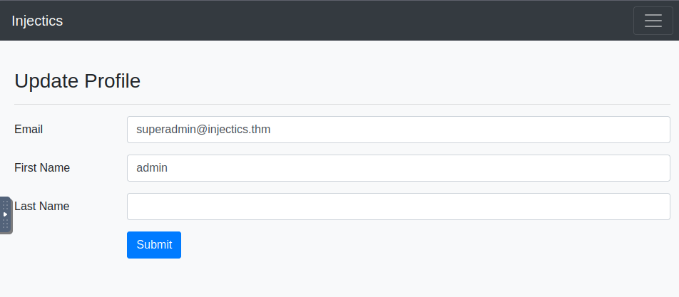
Recall the webserver using twig. I then try the following payload {{7*’7’}} to see if it is indeed susceptible to SSTI. If we get 49 as a result, then the webserver has a SSTI vulnerability.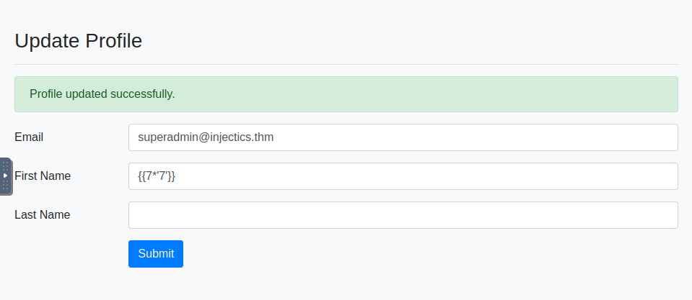
After going to the home page, we can see that the name has been updated to 49, which means SSTI is possible.
Next thing to do is try and find a payload that will escalate our privileges.
After researching about twig 2.14.0 vulnerability, I was able to find that the vulnerability exists in the “sort” filter (CVE-ID: CVE-2022-23614).
So, I tried this payload: {{ ['whoami',' ']|sort("passthru") }} and it worked.
Next thing to do is to get inside the /flags folder.
Replacing “whoami” with “ls -al flags” showed me the contents of the /flags folder which contained a txt file that most certainly has the flag.
Finally, I use the cat command to view the contents of the file: {{ ['cat /var/www/html/flags/5d8af1dc14503c7e4bdc8e51a3469f48.txt',' ']|sort("passthru") }} The 2nd flag is shown!

That’s the end of the walkthrough.

